**DATA - 200**

**Stock Analysis**

**Lab 2**

**Shibin Biji Thomas**

**018318261**

**Git Hub Link:** [**https://github.com/Shibin506/Shibin_PYTHON_LAB-2**](https://github.com/Shibin506/Shibin_PYTHON_LAB-2)

**1. Objective**

**The goal of Lab 2 is to extend our Python-based stock tracking application by incorporating external data sources. The lab introduces web scraping techniques using BeautifulSoup and Selenium, as well as CSV file imports to populate historical stock data into the application. This lab enhances both the GUI and console components of the app for real-time and bulk data ingestion.**

**2. 🛠️ Tools & Libraries Used**

* **Python (v3.x)**
* **Tkinter – GUI interface**
* **BeautifulSoup (bs4) – HTML parsing for scraping**
* **Selenium – Browser automation**
* **CSV – File reading/writing**
* **Matplotlib – Chart visualization**
* **SQLite – Embedded database (via stock_db.py)**

**GUI workflow**

**Stock Analysis Assistant**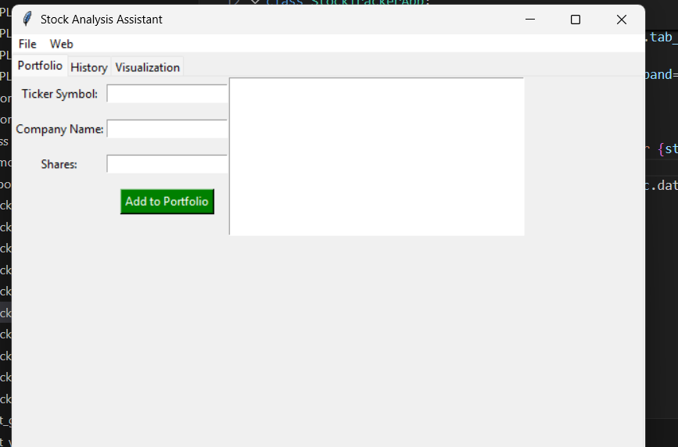

**Manually Adding Data**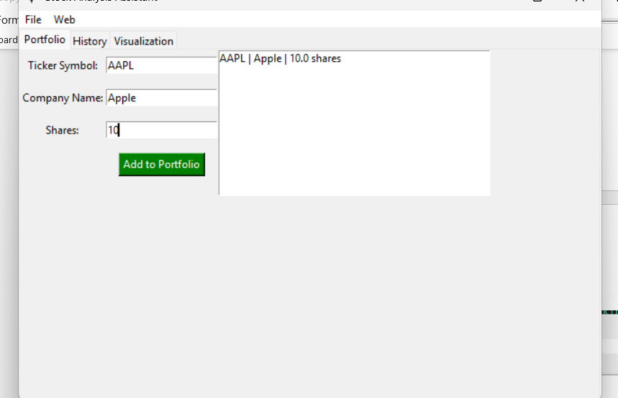

**Fetching Data**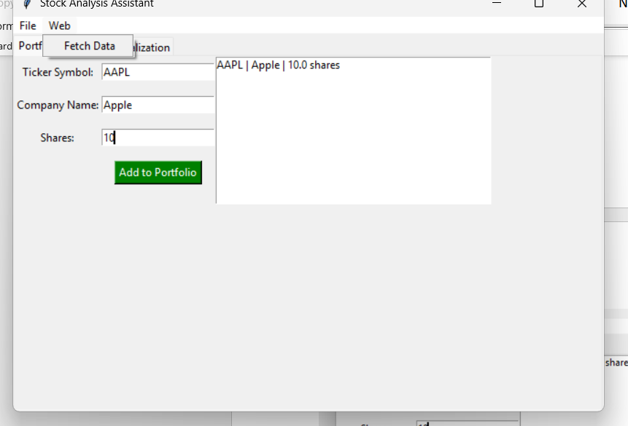

**Start Date**

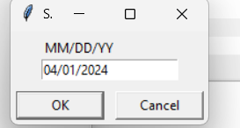

**Fetched 63 entries**

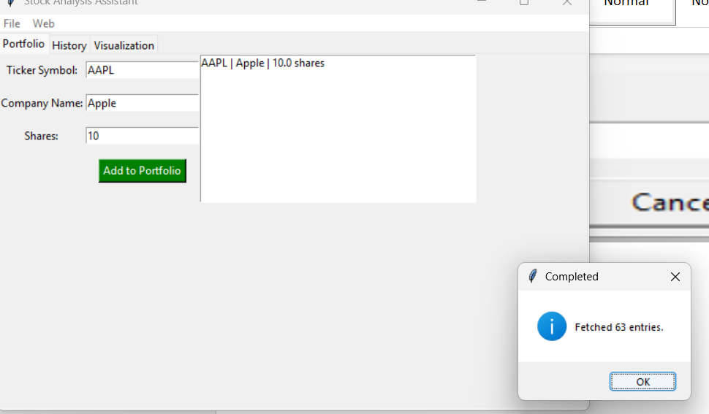

**AAPL Trend**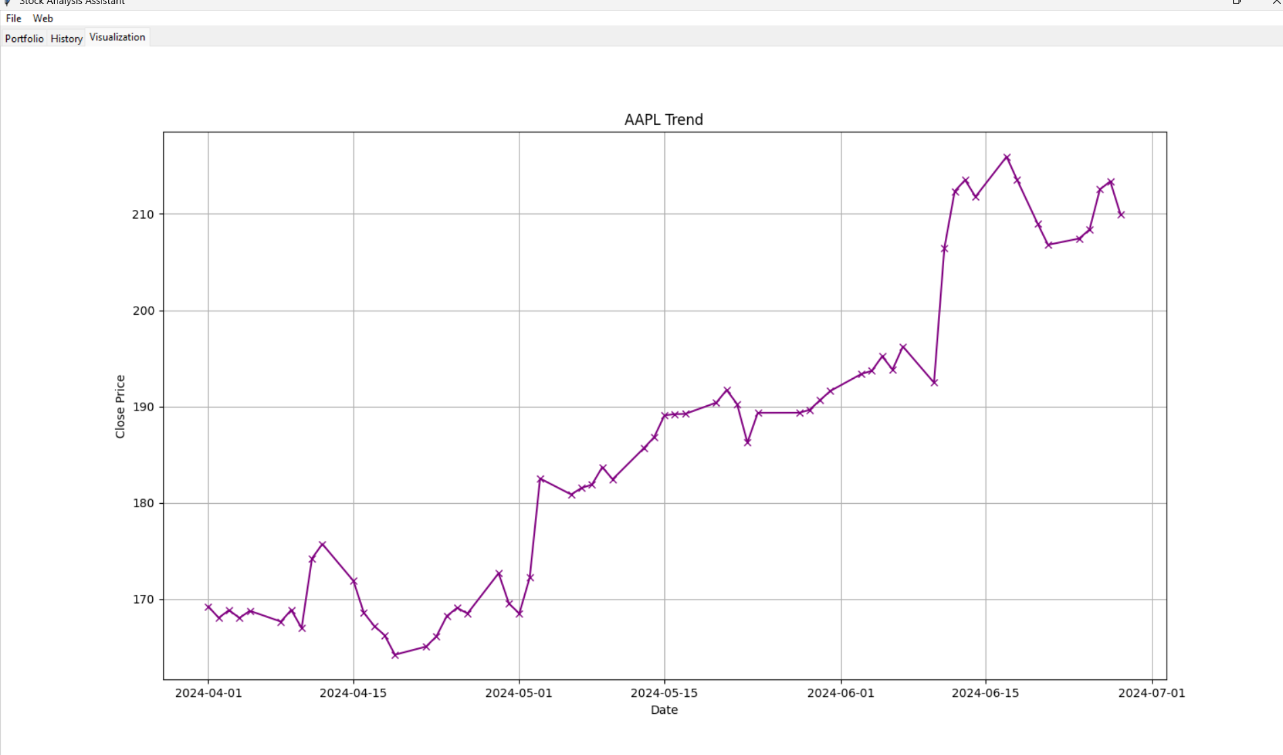

**Stock_db**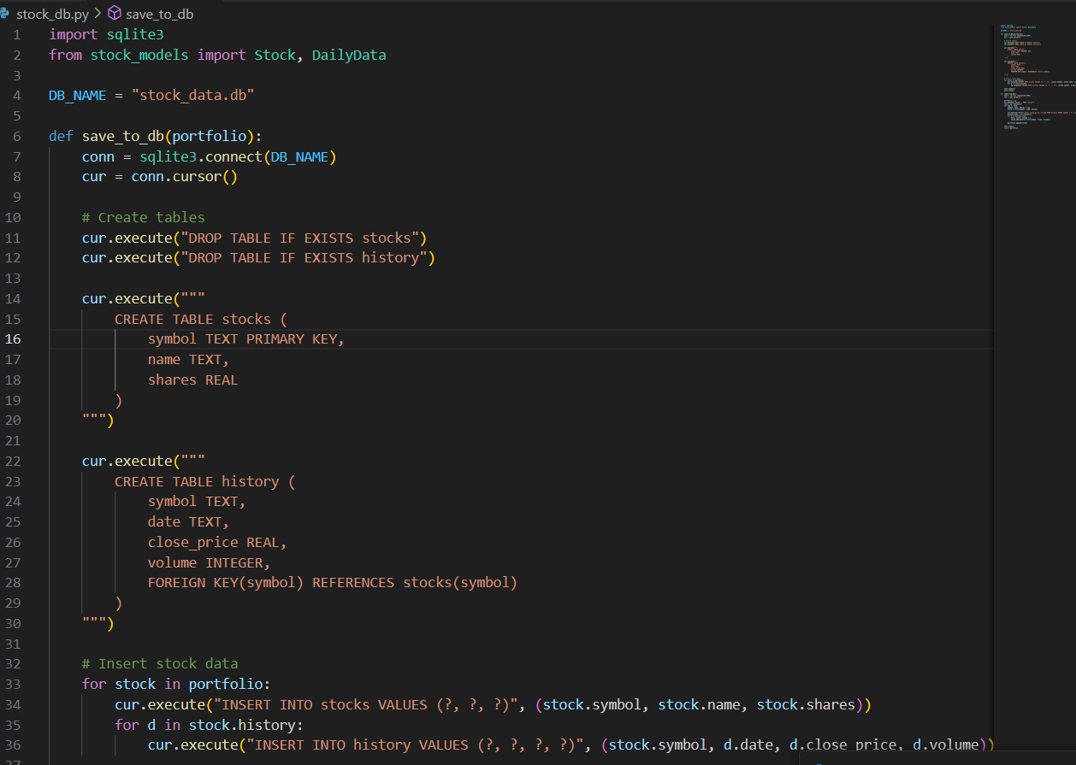

**Stock Console:**

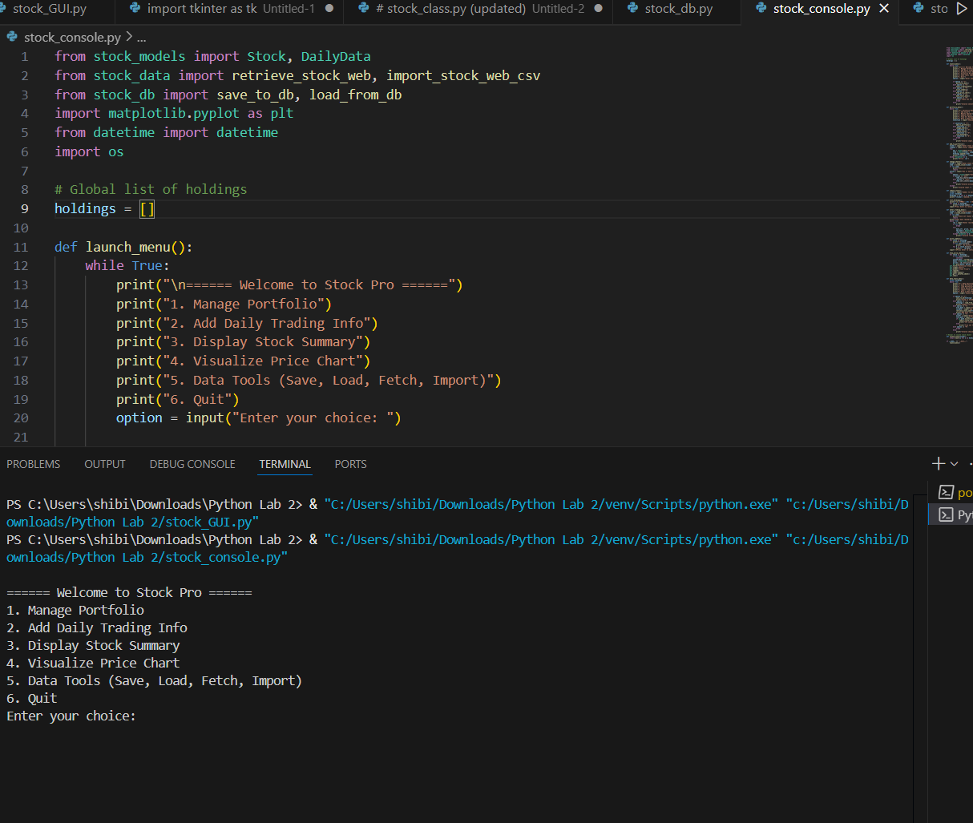

**Manually adding stock and fetching all the details.**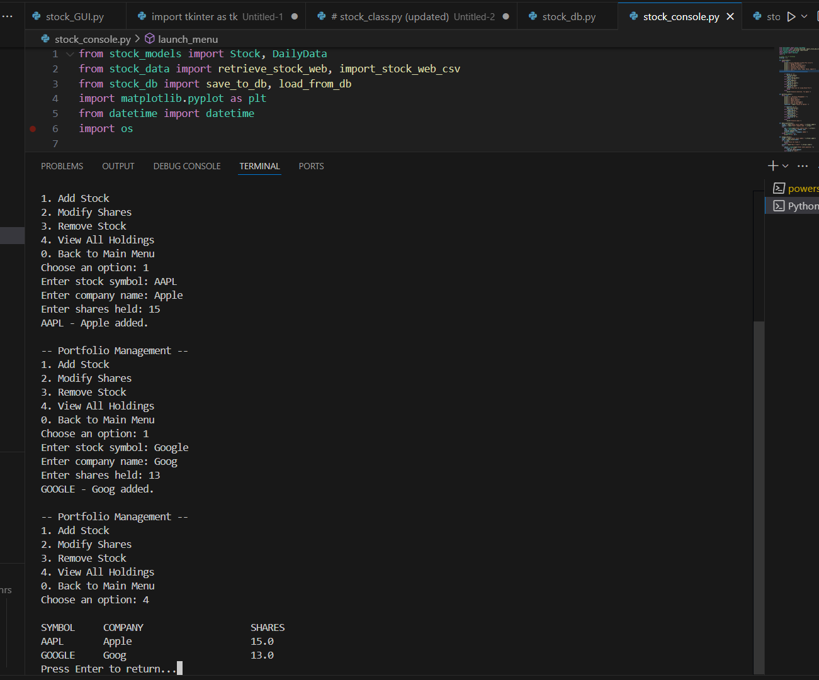

**Saving Portfolio**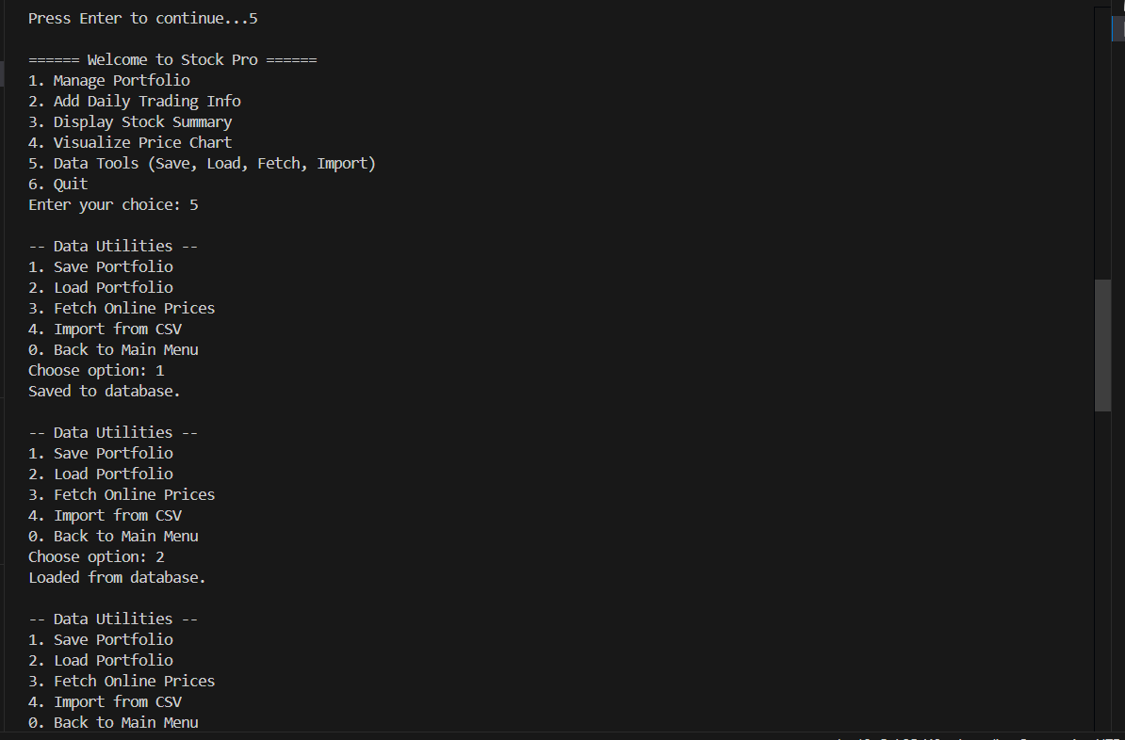

**Loading Portfolio**

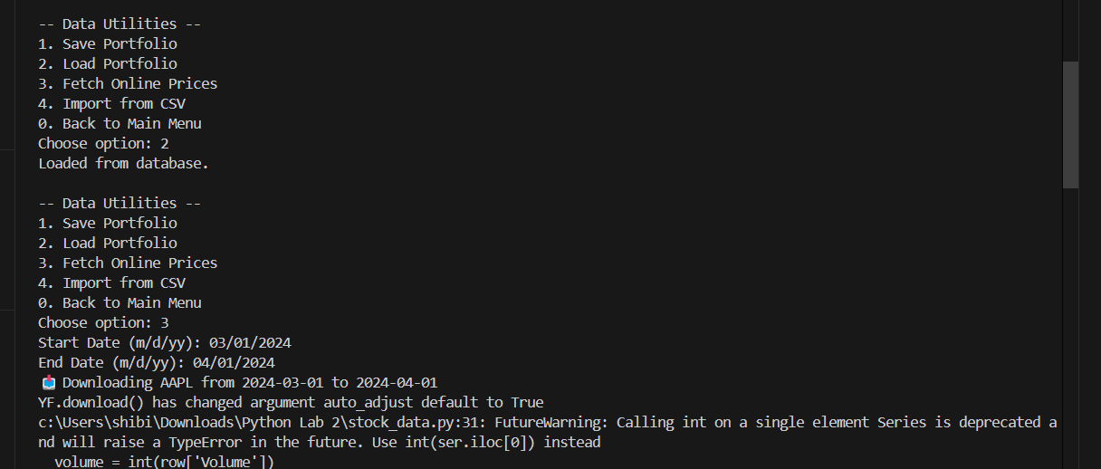

**Fetching Online Prices**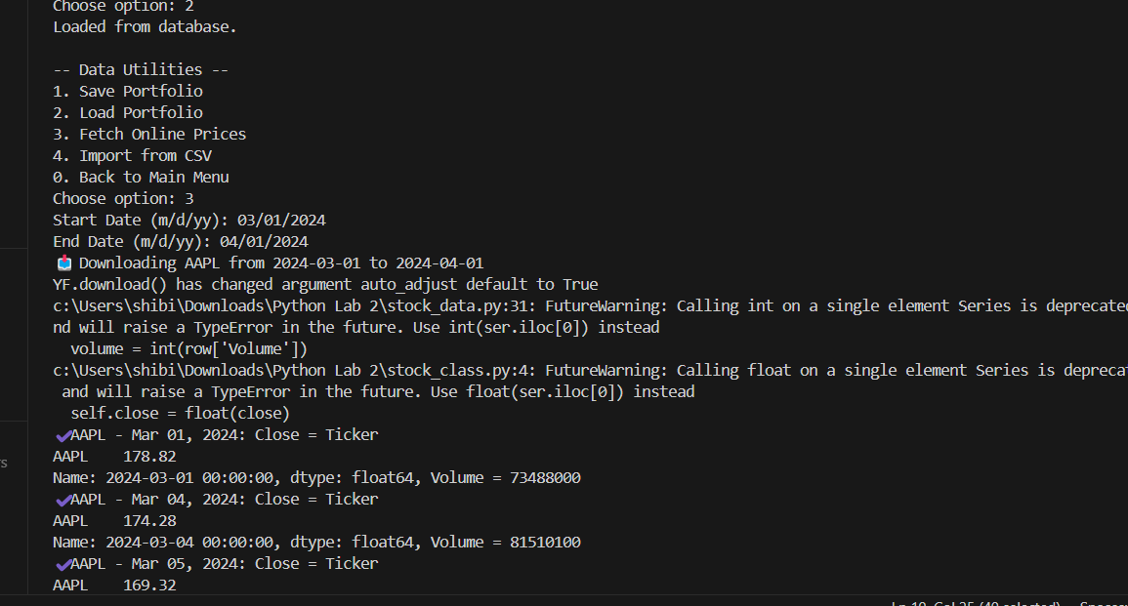

**Importing from CSV**

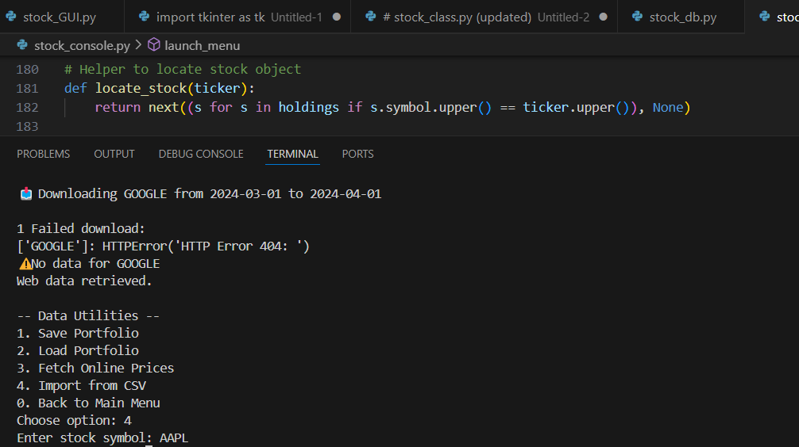

**Daily Trading Info doing selling and buying of stocks**

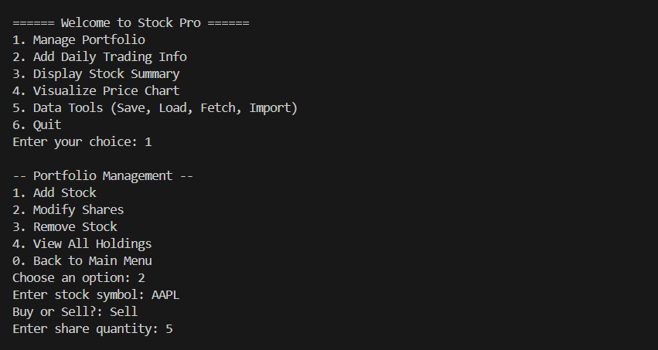

**Visualization**

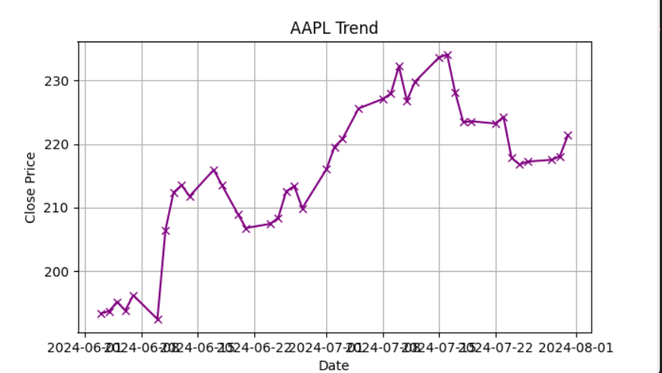

**Key Learnings & Insights (Summary)**

* **Gained practical experience with web scraping using Selenium and BeautifulSoup.**
* **Learned to import and process CSV files for financial data integration.**
* **Strengthened object-oriented programming skills by working with custom classes.**
* **Built both GUI and console interfaces to interact with stock data.**
* **Applied data visualization using matplotlib to generate stock price charts.**
* **Understood the importance of modular code, error handling, and step-by-step testing.**